EXPT NO:5 | DEVELOP INTERACTIVE DASHBOARDS FOR DYNAMIC DATA EXPLORATION USING TABLEAU AND POWERBI
DATE: 24.07.2026

PRE-LAB QUESTIONS (PROVIDE BRIEF ANSWERS TO THE FOLLOWING QUESTIONS)

- What is dynamic data exploration in BI tools, and why is it important?
Dynamic data exploration is the process of analyzing data interactively using BI tools like Tableau and Power BI. It allows users to filter, sort, and explore data from different perspectives without changing the original dataset. This helps users identify trends, patterns, and insights more easily. It also supports faster and more informed decision-making. Interactive exploration makes dashboards more useful and user-friendly.

- What are slicers and filters, and how do they enhance dashboard interactivity?
Slicers and filters allow users to display only the data they want to analyze. They help narrow down information based on categories such as date, region, or product. This makes dashboards more interactive and easier to use. Users can quickly compare different data without modifying the original dataset. They improve the overall user experience and analysis.

- How do Tableau and Power BI support drill-down and drill-through features?
Tableau and Power BI provide drill-down and drill-through features to explore data in greater detail. Drill-down lets users move from summary information to detailed data, such as Year → Month → Day. Drill-through opens another report page with related information. These features make dashboards more interactive and help users perform detailed analysis. They improve data exploration and decision-making.

- What is the role of parameters in creating interactive dashboards?
Parameters allow users to change values or settings in a dashboard without editing the underlying data. They can control calculations, filters, and visualizations based on user input. Parameters make dashboards more flexible and interactive. They help users compare different scenarios and customize the analysis. This improves the overall dashboard experience.

- Name some advanced interactivity features in Tableau and Power BI.
Some advanced interactivity features include filters, slicers, drill-down, drill-through, parameters, tooltips, and cross-filtering. Tableau also supports actions such as filter actions and highlight actions. Power BI provides bookmarks, buttons, and navigation features for interactive reports. These features make dashboards more engaging and easier to explore. They help users analyze data efficiently and gain better insights.

IN-LAB EXERCISE:
OBJECTIVE:
To design and develop interactive dashboards in Tableau and Power BI for dynamic data exploration, enabling users to analyze, filter, and drill down into data for deeper insights.
PROCEDURE:
- Data Collection:
    - Import datasets from sources such as Excel, CSV, SQL Server, or online APIs.
    - Dataset: Retail Sales Dataset with fields such as Order Date, Region, Product Category, Sales, Profit, Quantity.
- Data Preparation and Transformation:
    - Ensure proper date formats for time-based analysis. o Handle missing or incorrect values.
    - Create calculated fields (e.g., Profit Margin %, Sales Growth %, Year-to-Date Sales).
- Data Aggregation and Hierarchies:
    - Create hierarchies (e.g., Year → Quarter → Month → Day).
    - Aggregate data by region, product category, or customer segment.

- Designing Interactive Elements:
    - Filters & Slicers: Allow filtering by product category, date range, or region. o Parameters: Let users switch between KPIs (e.g., Sales vs. Profit). o Drill-down: Enable users to explore data from summary to detail.
    - Tooltips: Add contextual details when hovering over data points.
- Dashboard Development:
    - Tableau: Use interactive filters, parameter controls, and highlight actions.
    - Power BI: Use slicers, bookmarks, and drill-through pages.
    - Add KPI cards for key metrics like Total Sales, Total Profit, Top Selling Product. o Use maps for regional sales analysis, line charts for trends, and bar charts for category comparisons.
- Testing Interactivity:
    - Ensure slicers and filters update all relevant visuals dynamically.
    - Test drill-down and drill-through functionality for accuracy.
- Publishing and Sharing:
    - Tableau: Publish on Tableau Public or Tableau Server.
    - Power BI: Publish to Power BI Service and share via workspace access or public link.
Experiment Dataset:
Retail Sales Dataset
Fields Used:
  - Order Date – Date of the order
  - Region – Sales region
  - Product Category – Category of product sold
  - Sales – Sales revenue
  - Profit – Net profit from the order
  - Quantity – Units sold

Power BI
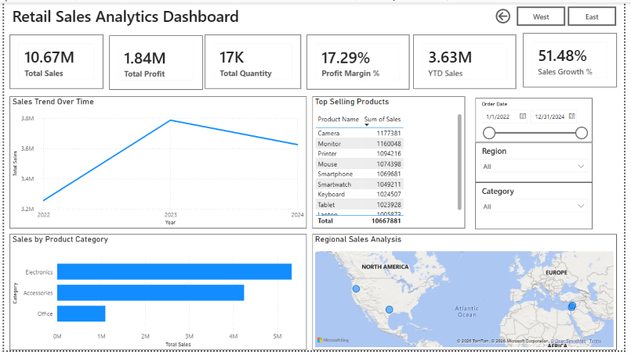

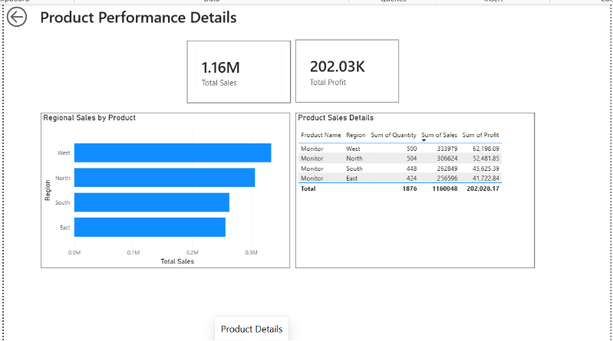

TABLEAU
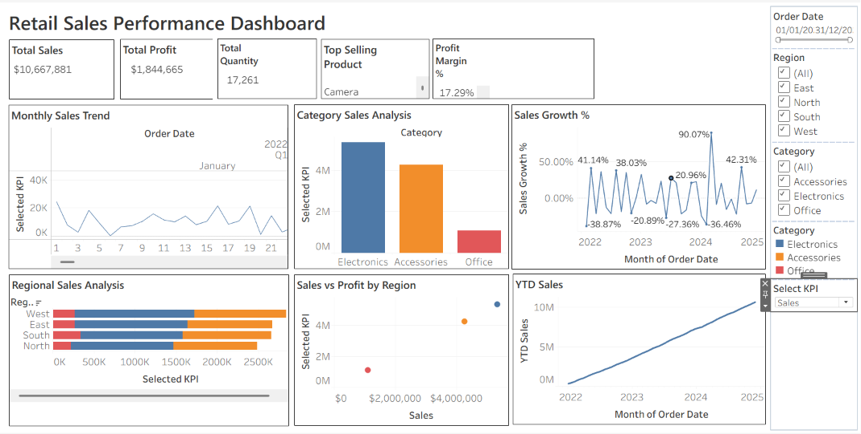

POST-LAB QUESTIONS (PROVIDE BRIEF ANSWERS TO THE FOLLOWING QUESTIONS)
- How did interactivity improve the analysis experience in your dashboard?
Interactivity made the dashboard much easier to explore and understand. I could quickly filter the data by region, category, and date without creating new reports. It helped me compare sales and profit across different conditions instantly. The visuals updated automatically based on my selections. This made the analysis faster and more meaningful. It also allowed me to identify trends and patterns with less effort.
- Which interactive feature (filters, drill-down, parameters, etc.) was most useful and why?

The filters and slicers were the most useful feature in my dashboard. They allowed me to focus on specific regions, categories, and time periods with just a few clicks. This made it easy to compare different business scenarios. It also reduced the time needed to find important insights. Overall, it improved the user experience. The dashboard became more flexible and easier to analyze.

- What challenges did you face while implementing drill-down or dynamic filters?

Initially, I had difficulty making all visuals respond correctly to the filters. Some charts were not updating because of incorrect relationships and visual interactions. Setting up the date hierarchy for drill-down also required extra attention. After adjusting the model and interactions, everything worked as expected. This helped me understand dashboard design better. It also improved my knowledge of data modeling and visualization.

- How do tooltips contribute to better dashboard storytelling?
Tooltips provide extra details without making the dashboard look crowded. They allow users to see important values by simply hovering over a chart. This helps explain the data more clearly and improves understanding. Users can get additional context without leaving the current view. As a result, the dashboard becomes more informative and interactive. They also make it easier to interpret trends and compare values.

- What additional features would you add to make the dashboard more insightful?
I would add forecasting to predict future sales trends based on historical data. Customer segmentation and product-level drill-through pages would provide deeper business insights. I would also include alerts for low profit margins and sales targets. A comparison with previous year performance would make trend analysis easier. These features would make the dashboard even more useful for decision-making. They would help users identify opportunities and make better business decisions more quickly.

RESULT:

The retail sales dataset was successfully transformed, aggregated, and visualized into interactive dashboards in Tableau and Power BI. Filters, slicers, drill-downs, and parameters enabled dynamic exploration of sales and profit trends by region, product category, and time period. The resulting dashboards allowed for quick insights and deeper analysis, enhancing decision-making capabilities.

ASSESSMENT

Description |  | Max Marks | Marks Awarded
Pre Lab Exercise |  | 5
In Lab Exercise |  | 10
Post Lab Exercise |  | 5
Viva |  | 10
 | Total | 30
 | Faculty Signature

